WEEK – 7 REACT HANDSON
REACT JS _HANDSON -9
Create a React Application named “cricketapp” with the following components:
- ListofPlayers
- Declare an array with 11 players and store details of their names and scores using the map feature of ES6
- IndianPlayers

  - Display the Odd Team Player and Even Team players using the Destructuring features of ES6

IndianPlayers.jsx

import React from 'react';

const IndianPlayers = () => {
const oddTeam = ['Virat', 'Gill', 'Pandya', 'Ashwin', 'Kuldeep'];
const evenTeam = ['Rohit', 'Rahul', 'Jadeja', 'Bumrah', 'Shami'];
const [p1, p2, p3, p4, p5] = oddTeam;
const [q1, q2, q3, q4, q5] = evenTeam;

const T20 = ['Surya', 'Hardik'];
const Ranji = ['Prithvi', 'Shreyas'];
const merged = [...T20, ...Ranji];

return (
<div>
<h2>Odd Team</h2>
<ul><li>{p1}</li><li>{p2}</li><li>{p3}</li><li>{p4}</li><li>{p5}</li></ul>

<h2>Even Team</h2>
<ul><li>{q1}</li><li>{q2}</li><li>{q3}</li><li>{q4}</li><li>{q5}</li></ul>

<h2>Merged Players</h2>
<ul>{merged.map((p, i) => <li key={i}>{p}</li>)}</ul>
</div>
);
};

export default IndianPlayers;

ListofPlayers.jsx

import React from 'react';
const ListofPlayers = () => {
const players = [
{ name: 'Virat', score: 90 },
{ name: 'Rohit', score: 45 },
{ name: 'Gill', score: 75 },
{ name: 'Rahul', score: 68 },
{ name: 'Pandya', score: 85 },
{ name: 'Jadeja', score: 40 },
{ name: 'Ashwin', score: 77 },
{ name: 'Bumrah', score: 88 },
{ name: 'Shami', score: 32 },
{ name: 'Kuldeep', score: 72 },
{ name: 'Surya', score: 95 }
];

const below70 = players.filter(player => player.score < 70);

return (
<div>
<h2>All Players</h2>
<ul>{players.map((p, i) => <li key={i}>{p.name} - {p.score}</li>)}</ul>

<h3>Scores below 70</h3>
<ul>{below70.map((p, i) => <li key={i}>{p.name} - {p.score}</li>)}</ul>
</div>
);
};

export default ListofPlayers;

App.jsx

import ListofPlayers from './components/ListofPlayers';
import IndianPlayers from './components/IndianPlayers';

function App() {
const flag = true; // Change to false to see IndianPlayers

return (
<div>
<h1>🏏 Cricket App</h1>
{flag ? <ListofPlayers /> : <IndianPlayers />}
</div>
);
}

export default App;
OUTPUT:

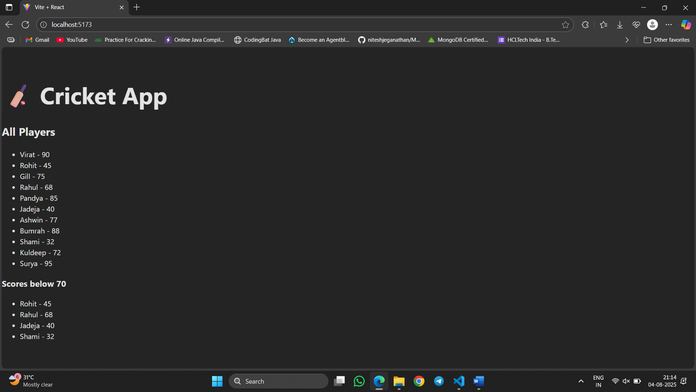

REACTJS_HANDSON-10
Estimated time to complete this lab: 60 minutes.
Create a React Application named “officespacerentalapp” which uses React JSX to create elements, attributes and renders DOM to display the page.

Create an element to display the heading of the page.
Attribute to display the image of the office space
Create an object of office to display the details like Name, Rent and Address.
Create a list of Object and loop through the office space item to display more data.
To apply Css, Display the color of the Rent in Red if it’s below 60000 and in Green if it’s above 60000.

App.jsx
import React from 'react';
import './App.css'; // Optional if you use class-based styling

function App() {
const imageSrc = "https://tse4.mm.bing.net/th/id/OIP.qwMMUwvJP0EalVHgk2mDzwHaD4?rs=1&pid=ImgDetMain&o=7&rm=3";
const element = "Office Space";
const ItemName = { Name: "DBS", Rent: 50000, Address: "Chennai" };
const rentStyle = {
color: ItemName.Rent <= 60000 ? 'red' : 'green',
fontWeight: 'bold',
fontSize: '18px'
};

// JSX image element
const jsxatt = (
<img
src={imageSrc}
width="40%"
height="auto"
alt="Office Space"
style={{ margin: '20px 0', borderRadius: '8px' }}
/>
);

return (
<div style={{ textAlign: 'center', fontFamily: 'Arial, sans-serif', padding: '20px' }}>
<h1>{element}, at Affordable Range</h1>
{jsxatt}

<h2>Name: {ItemName.Name}</h2>
<p style={rentStyle}>Rent: Rs. {ItemName.Rent}</p>
<p>Address: {ItemName.Address}</p>
</div>
);
}

export default App;

OUTPUT:
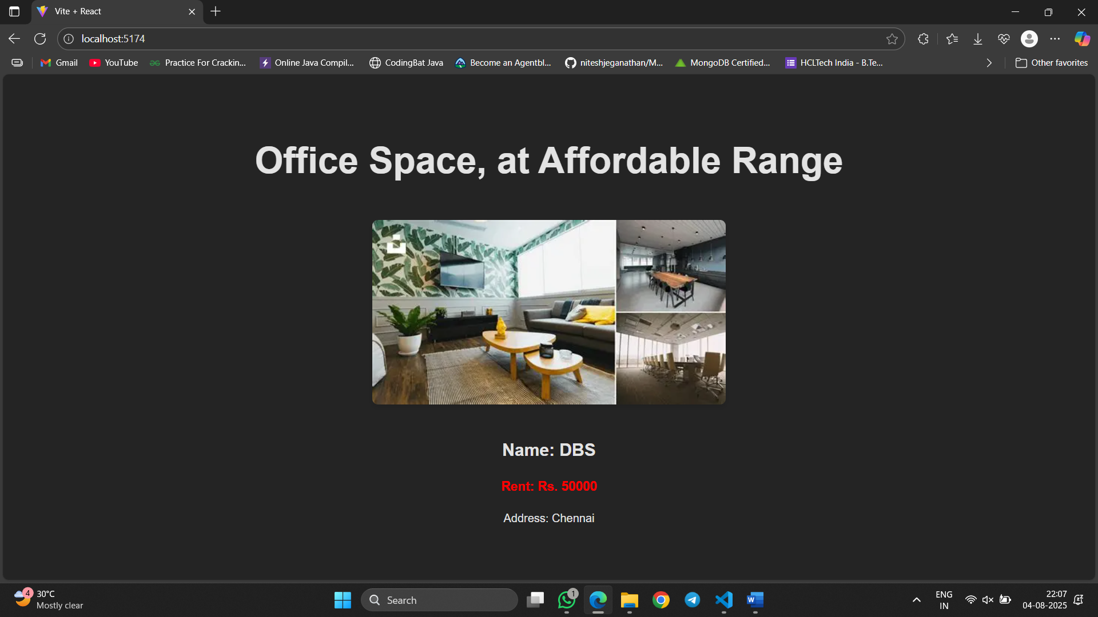

REACTJS_HANDSON-11
Create a React Application “eventexamplesapp” to handle various events of the form elements in HTML.
- Create “Increment” button to increase the value of the counter and “Decrement” button to decrease the value of the counter. The “Increase” button should invoke multiple methods.
CurrencyConvertor.jsx
import React, { useState } from 'react';
const CurrencyConvertor = () => {
const [rupees, setRupees] = useState('');
const [euro, setEuro] = useState('');
const handleConvert = (e) => {
e.preventDefault();
const converted = (rupees / 88).toFixed(2); // Assuming 1€ = ₹88
setEuro(converted);
};
return (
<div style={{ marginTop: '20px' }}>
<h3>Currency Converter (INR to EUR)</h3>
<input
type="number"
value={rupees}
onChange={(e) => setRupees(e.target.value)}
placeholder="Enter amount in INR"
/>
<button onClick={handleConvert}>Convert</button>
{euro && <p>€ {euro}</p>}
</div>
);
};

export default CurrencyConvertor;
App.jsx
import React, { useState } from 'react';
import CurrencyConvertor from './components/CurrencyConvertor';

function App() {
const [count, setCount] = useState(0);

// Event handler with multiple actions
const handleIncrement = () => {
setCount(prev => prev + 1);
sayHello();
};

const sayHello = () => {
alert("Hello! Count has increased.");
};

const sayWelcome = (msg) => {
alert(msg);
};

const handleSyntheticClick = (e) => {
alert(`Synthetic Event Triggered: ${e.type}`);
};

return (
<div style={{ padding: '30px', fontFamily: 'Arial' }}>
<h1>React Event Handling Lab</h1>

<h2>Counter: {count}</h2>
<button onClick={handleIncrement}>Increment</button>
<button onClick={() => setCount(prev => prev - 1)}>Decrement</button>

<br /><br />

<button onClick={() => sayWelcome("Welcome to EventExamplesApp!")}>Say Welcome</button>

<br /><br />

<button onClick={handleSyntheticClick}>Synthetic Event Button</button>

<CurrencyConvertor />
</div>
);
}

export default App;

OUTPUT:
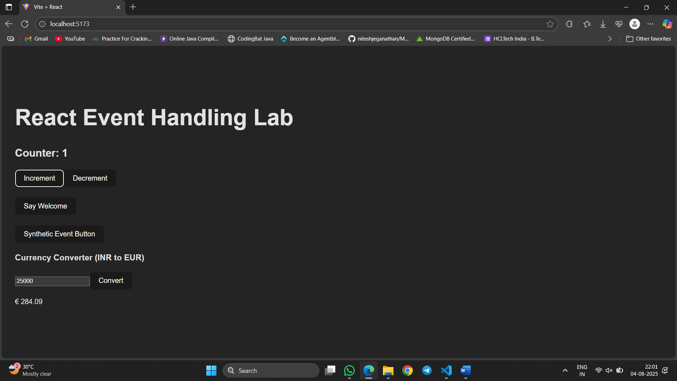
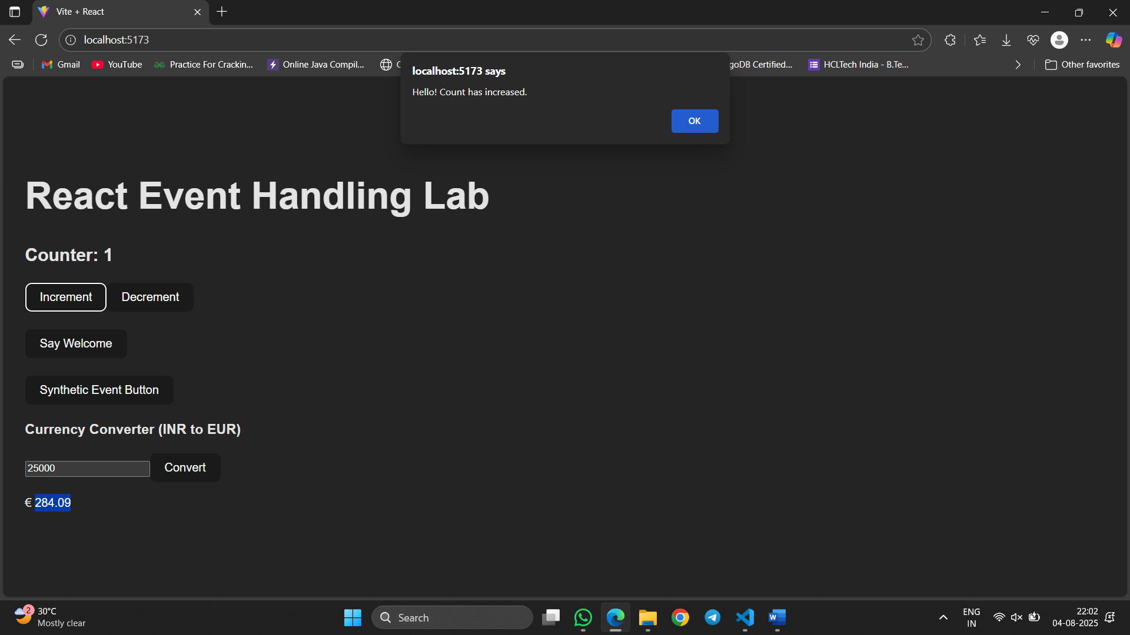

REACTJS_HANDSON-12
Create a React Application named “ticketbookingapp” where the guest user can browse the page where the flight details are displayed whereas the logged in user only can book tickets.
The Login and Logout buttons should accordingly display different pages. Once the user is logged in the User page should be displayed. When the user clicks on Logout, the Guest page should be displayed.
GuestPage.jsx

import React from 'react';
const GuestPage = () => {
return (
<div style={{ padding: '20px' }}>
<h2>Welcome, Guest!</h2>
<p>You can browse available flights but must log in to book tickets.</p>
</div>
);
};
export default GuestPage;

UserPage.jsx
import React from 'react';

const UserPage = () => {
return (
<div style={{ padding: '20px' }}>
<h2>Welcome, User!</h2>
<p>You are now logged in and can book your flight tickets.</p>
</div>
);
};

export default UserPage;

App.jsx

import React, { useState } from 'react';
import GuestPage from './components/GuestPage';
import UserPage from './components/UserPage';

function App() {
const [isLoggedIn, setIsLoggedIn] = useState(false);

const toggleLogin = () => {
setIsLoggedIn(prev => !prev);
};

return (
<div style={{ textAlign: 'center', fontFamily: 'Arial', padding: '30px' }}>
<h1>✈️ Ticket Booking App</h1>

<button onClick={toggleLogin} style={{ padding: '10px 20px', marginBottom: '20px' }}>
{isLoggedIn ? 'Logout' : 'Login'}
</button>

{isLoggedIn ? <UserPage /> : <GuestPage />}
</div>
);
}

export default App;

OUTPUT:
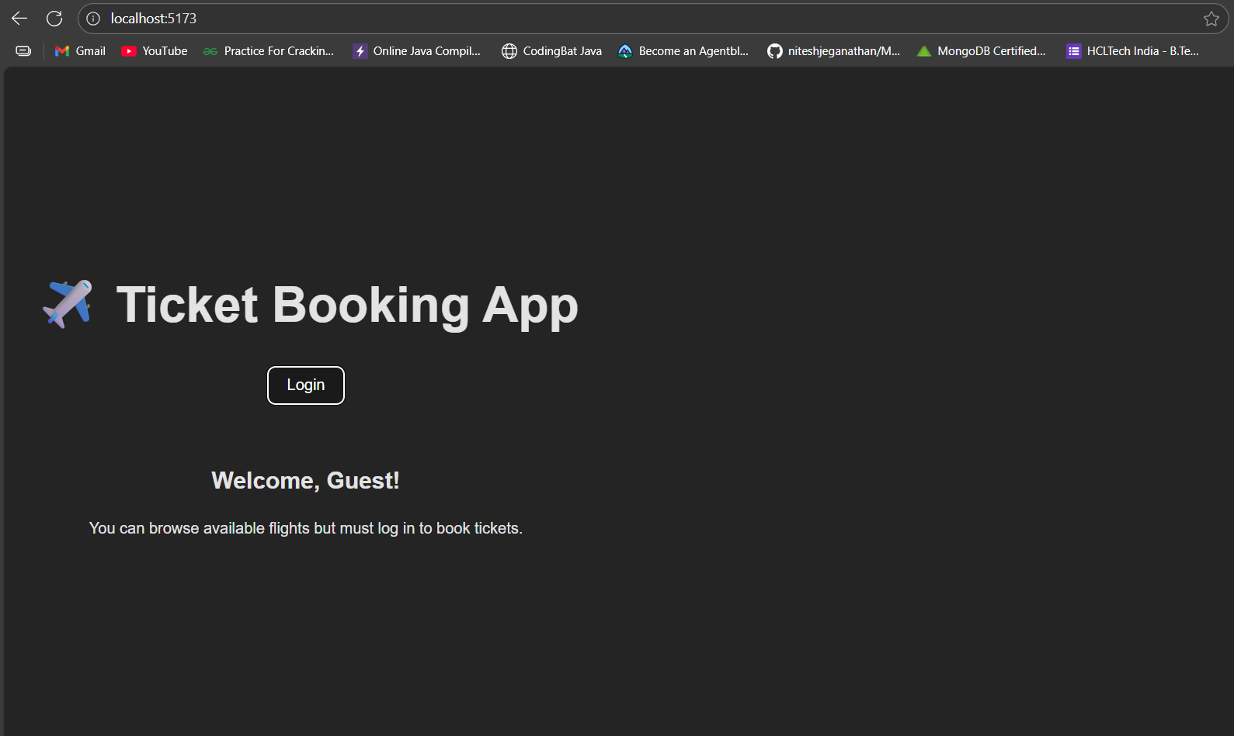

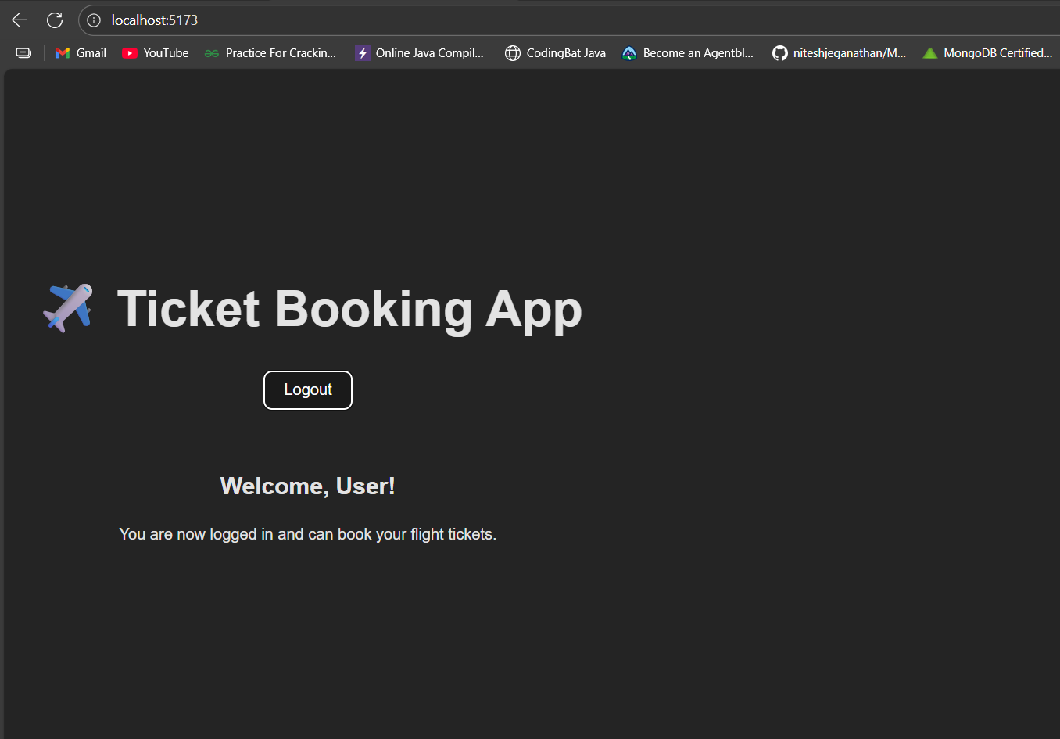

REACTJS_HANDSON-13
Create a React App named “bloggerapp” in with 3 components.
- Book Details
- Blog Details
- Course Details
Implement this with as many ways possible of Conditional Rendering.

CourseDetails.jsx
import React from 'react';

const CourseDetails = () => {
const courses = [
{ name: 'Angular', date: '4/5/2021' },
{ name: 'React', date: '6/3/2021' }
];

return (
<div className="box">
<h2>Course Details</h2>
{courses.map((c, index) => (
<div key={index}>
<p><strong>{c.name}</strong></p>
<p>{c.date}</p>
</div>
))}
</div>
);
};

export default CourseDetails;

BookDetails.jsx
import React from 'react';

const BookDetails = () => {
const books = [
{ title: 'Master React', price: 670 },
{ title: 'Deep Dive into Angular 11', price: 800 },
{ title: 'Mongo Essentials', price: 450 }
];

return (
<div className="box">
<h2>Book Details</h2>
{books.map((book, index) => (
<div key={index}>
<p><strong>{book.title}</strong></p>
<p>{book.price}</p>
</div>
))}
</div>
);
};

export default BookDetails;

BlogDetails.jsx
import React from 'react';

const BlogDetails = () => {
const blogs = [
{
title: 'React Learning',
author: 'Stephen Biz',
content: 'Welcome to learning React!'
},
{
title: 'Installation',
author: 'Schwezdenier',
content: 'You can install React from npm.'
}
];
return (
<div className="box">
<h2>Blog Details</h2>
{blogs.map((blog, index) => (
<div key={index}>
<p><strong>{blog.title}</strong></p>
<p><em>{blog.author}</em></p>
<p>{blog.content}</p>
</div>
))}
</div>
);
};

export default BlogDetails;
App.jsx
import React from 'react';
import CourseDetails from './components/CourseDetails';
import BookDetails from './components/BookDetails';
import BlogDetails from './components/BlogDetails';
import './App.css';

function App() {
return (
<div className="container">
<CourseDetails />
<BookDetails />
<BlogDetails />
</div>
);
}
export default App;
OUTPUT:
